Independent Living Fund Scotland

Scottish Recipient Advisory Group Meeting Minutes
Monday 23 August 2021

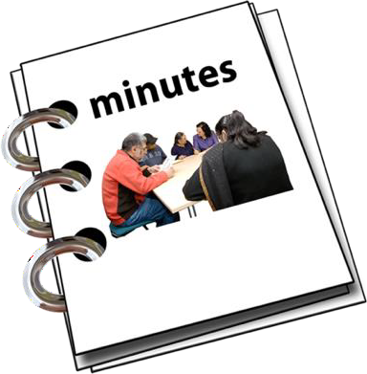
Easy Read

Copyright images © Photosymbols. Prepared by Disability Equality Scotland

 | In this document recipient means someone who is given money by the Independent Living Fund Scotland.
 | 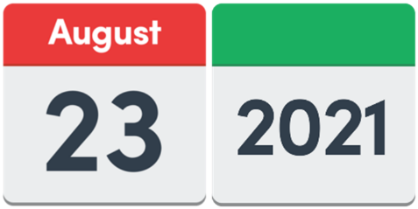 |  | The meeting happened on Monday 23 August 2021 from 1pm to 3pm.
 |  |  | The meeting happened on Zoom.
Who was at this meeting?
Jim Elder-Woodward
Andy Higgins
Joan Turner
Kate Walsh
Christine Mercer

Linda Scott
Peter Scott
Alannah Norton

Who could not come?
Hugh John-Glancy
Chloe McKee
Gordon McKee
Nic Reid
6 Actions from this meeting
- Linda will email the Advisory Group when the Minister, Kevin Stewart, has given a new date to meet with the Group.
- The Charter for Involvement will be discussed at every meeting starting from the next meeting.
- Linda will check with the Centres for Independent Living to see if they want a session about the Charter for Involvement.
- There will be another meeting to talk about the Review of Adult Social Care consultation.
- Linda will send round the Terms of Reference again so that the Advisory Group can add their comments.
- The Terms of Reference will be added to the next meeting so that they can be agreed and signed off in November.
1. Welcome
Jim welcomed everyone.
 | 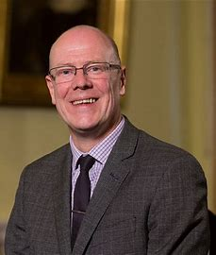 |  | 2. Minister for Mental Wellbeing and Social Care  Kevin Stewart is the Minister for Mental Wellbeing and Social Care.  He could not come to this meeting.  The group agreed that the Minister should come to a meeting before the November Advisory Group meeting.
3. The Minutes of the last Meeting
Everyone agreed that the Minutes from the last meeting were fine.
4. Any other things we need to talk about
The Advisory Group decided that the Charter for Involvement will be discussed at every meeting.
This will begin at the next meeting.

5. Updates about Policies, including COVID-19
Peter talked about the 500 hundred pound Thank You applications.
He said that the payments had been going smoothly apart from small problems.
The Advisory Group talked about their Personal Assistants getting this payment.

They were very thankful to get it.
Linda told everyone about the review of all the Independent Living Fund Scotland’s policies.
The review isfinished. Linda has talked to staff so that they understand the changes.

 | 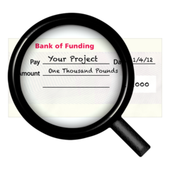 |  |  | Policy 41 is about using funding.  It makes sure that funds can be used in different ways.
6. Review Visits

Linda talked about review visits happening again.

Independent Living Fund Scotland are organising the visits.

They will begin with the recipients who need a visit the most.

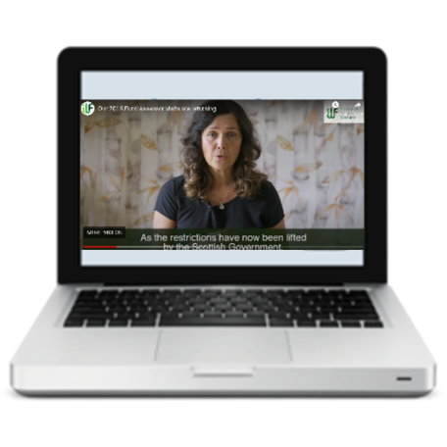 |  |  |  | There is a video on the website to explain how visits will happen.
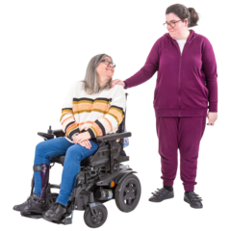 |  |  |  | 7. Policy 31 – about family who live with a Recipient, and are their paid Carer (Personal Assistant)  Some family members acted as Personal Assistants because of Covid 19.  This was a temporary arrangement and families should now go back to using the Personal Assistant or care provider they used before COVID-19 because the flexible payments under the policy will be stopping.
8. Policy 26 – about who looks after someone’s Independent Living Fund Scotland Award
The Award manager is the person who looks after the paperwork and makes sure the recipient gets their money.

There were talks about who can and who can’t be Award managers.

A few cases need to be looked at – like when a legal guardian is also an Award manager. This shouldn’t happen.
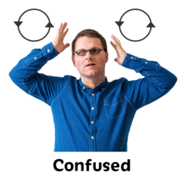 |  |  |  |  | 9. Your Responsibilities guide and Employer support  Some Award managers say they don’t feel confident about their role.
There will be some information sessions to help them.

Some Advisory Group members will join the sessions to see how they run, in case there are more sessions in the future.

Linda will check with the Centres of Independent Living to see if they want their own session.

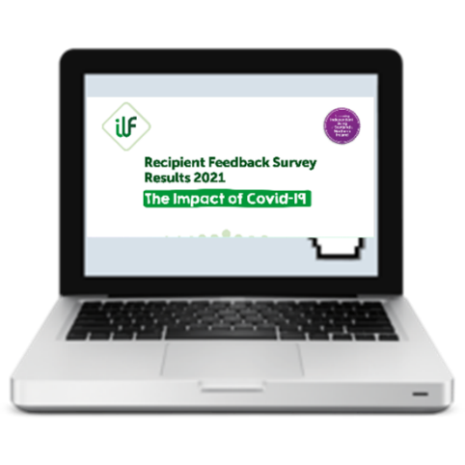 |  |  |  |  | 10. Feedback from the Recipient Survey  This survey is now finished.  The feedback has been made into a document that is easy to understand.  You can click here on the website and open the link you find there.
11. Review of Adult Social Care
Peter and Jim talked about the group meeting. They said that a consultation about adult social care has begun.

 |  |  |  | A consultation is when the Scottish Government asks people for their views about making changes.
 | 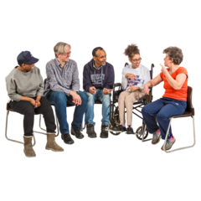 |  |  | Independent Living Fund Scotland will send in a response to the the consultation.
12. Terms of Reference
The group talked about changes to the Terms of Reference.
Linda will send everyone the Terms of Reference so that they can add their comments.
13. Choosing a new Chairperson and Vice Chairperson

The group agreed that Jim Elder-Woodward can carry on as the Chairperson of the Recipient Advisory Group.

The group agreed that Andy Higgins will be the Vice Chairperson.
14. Any other business

There was nothing else to talk about.
15. Date of the next meeting

The next meeting will be on Monday 22 November 2021.

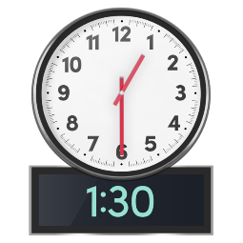  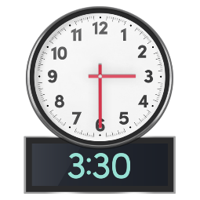 |  | It will be from 1.30pm to 3.30pm.
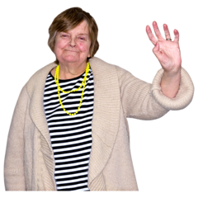 |  | This is the end of the Minutes.

