Independent Living Fund Scotland

Scottish Recipient Advisory Group Meeting Minutes
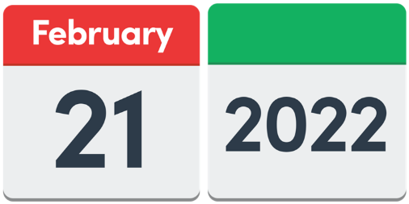
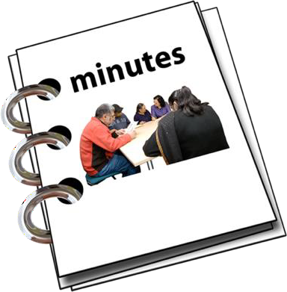
21 February 2022

Easy Read

Copyright images © Photosymbols. Prepared by Disability Equality Scotland

 |  |  |  |  |  | The meeting happened on Monday 21 February 2022 from 1pm to 3pm.
 |  |  |  |  |  | The meeting happened on Zoom.
Who was at this meeting?
Jim Elder-Woodward
Chloe Mckee
Gordon Mckee
Andy Higgins
Kate Walsh
Joan Turner
Hugh John-Glancy
Nic Reid
Peter Scott
Lee House
Linda Scott
Emma O’Neill
Robert White
Who could not come?

Christine Mercer

4 Actions from this meeting

- Lee will send out electronic feedback forms.

 |  |  |  |  |  | 2. Peter and Linda will talk to the sponsor team about possibly having a public holiday for Personal Assistants, for the Queen’s Jubilee.
 |  |  |  |  |  | 3. Linda will send a new copy of the Terms of Reference to everyone in the group.
 |  |  |  |  |  | 4. Linda will share information about Employer National Insurance costs.
1. Welcome and Introductions
Jim welcomed everyone.
He asked if everyone was okay with the meeting being recorded.
Everyone agreed.

 |  |  |  |  |  | 2. Action from the last Meeting
Lee will send out Marianne’s Charter for Involvement presentation.
This has been done.

3. Any other things we need to talk about
Linda said she will tell everyone about the award manager sessions later in the meeting.
- Scottish Social Care wages going up

Wages mean the money that a worker is paid for doing their job.
 |  |  | 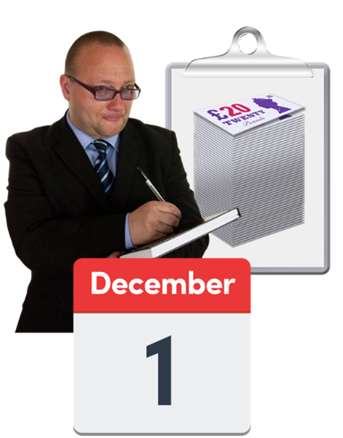 |  |  |  | Linda said that the new Social Care wage is 10 pounds and 2 pence an hour.  But the Independent Living Fund Scotland has added 5 and a half percent to all awards from 1 December 2021.
 |  |  |  |  |  |  | The Scottish Social Care new wages will be 10 pounds and 50 pence an hour from 1 April 2022.
Independent Living Fund Scotland won’t add this pay rise to care provider rates.
But it will look at pay rises in the future in each case.
 |  |  | 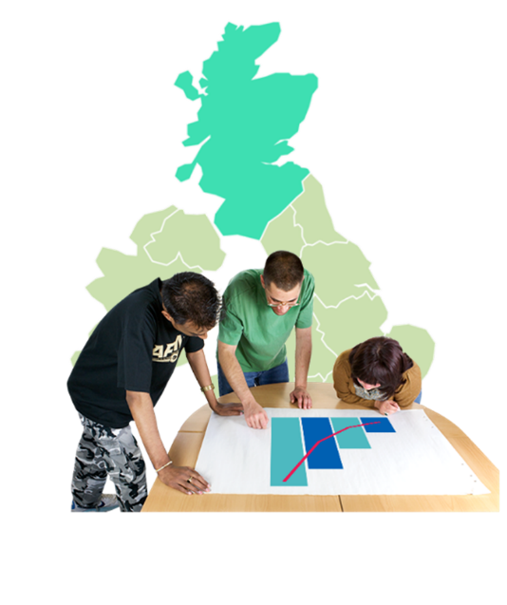 |  |  |  | - Possibly opening the 2015 Fund again  Linda said that the Minister has asked his team to find out more information from Local Authorities.  This will help to decide about opening the Fund.
6. Policy Updates

Policy 26 is called Managing an ILF Scotland Award.
Linda said it will get looked at and changed in 2022.

She will send the new copy of Policy 26 to all the group members for their thoughts.

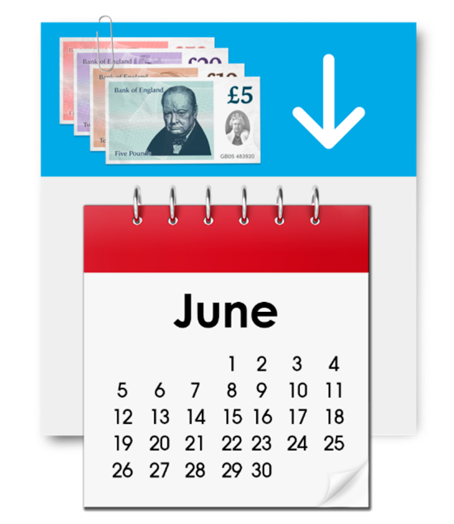 |  |  |  |  |  |  | Linda said that COVID-19 payments will probably carry on until June 2022.  This means that when Recipients don’t get their normal support, we can pay for support in the meantime.
 |  |  |  |  |  |  |  | Robert White joined the meeting at just after 1.30pm.
 | 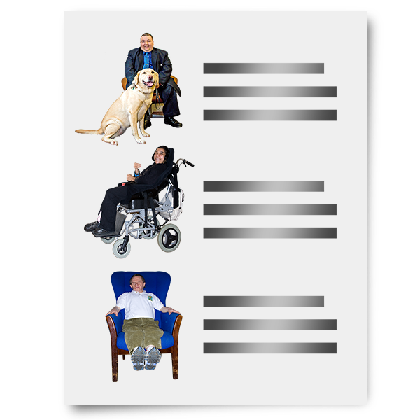 |  |  |  |  |  |  | 7. Review Visits, Review Reports and Data Protection  Robert said that reviews have started again now.  He said that each review takes 2 or 3 hours.
Robert said that Recipients don’t have to fill in a form to ask for their copy of the review visit report.

Instead they can ask their Assessor or the team.

 |  |  |  |  |  |  |  | Peter Scott joined the meeting just after 1.45pm.
- Feedback about Electronic Forms

Lee will email out the electronic feedback forms for the group to:
- look at
- see if there are any changes to be made
 |  |  | 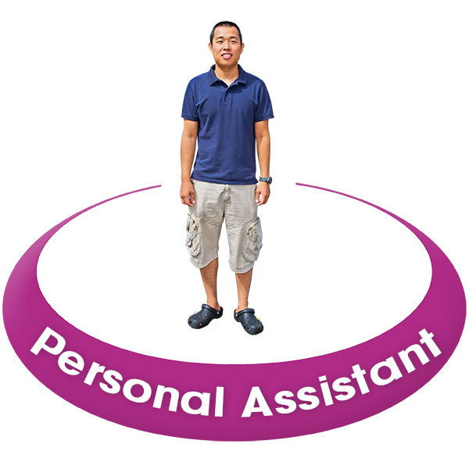 |  |  |  | 9. Personal Assistants  Linda asked everyone how easy or hard it is to:  - get new Personal Assistants working  - keep Personal Assistants without them leaving their role
The group talked about things like:
- adverts for Personal Assistant jobs
- how much pay
- work hours
 |  |  | 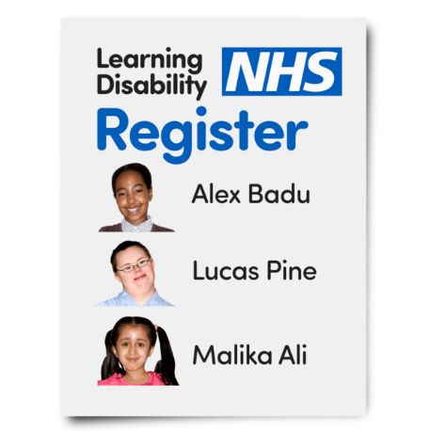 |  |  |  | 10. Personal Assistants Register  A register is a list of names and details.  Peter said that the Programme Board want Personal Assistants to:  - be on a register  - follow the same rules
 |  |  |  |  |  |  | But at the moment Personal Assistants are allowed to choose if they want to be on the register or not.
 |  |  |  |  |  |  | Peter said it is important that organisations that support disabled people’s rights are happy with changes in the future.
11. Charter for Involvement

Linda said that a report is being written about how things are going.
The report will be sent to the Board.
Linda said she will talk about it at the next meeting in May 2022.

12. Queens Jubilee

Personal Assistants might get an extra holiday for the Queens Jubilee.

Peter said he and Linda will talk to the Sponsor Team about this. Then Linda will tell the group.

13. Employers National Insurance

Jim asked why Independent Living Fund Scotland does not pay for Employers National Insurance.
 |  |  |  | 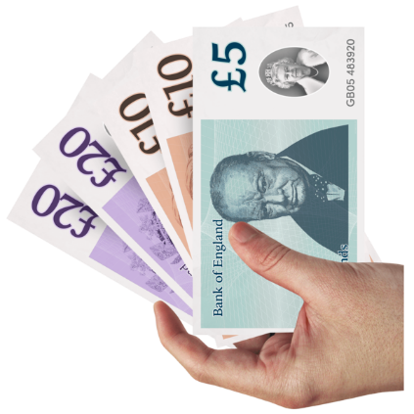 | Linda said that we can pay something towards Employers National Insurance if the year’s cost is over 4 thousand pounds.
 |  |  |  | 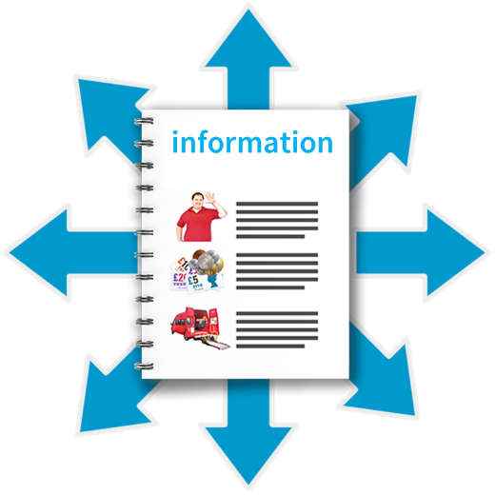 | There is information about this on an Employer Support Information Note.  Linda will share this information with the group.
14. Terms of Reference

Linda said she will talk with Jim about a final draft copy of the Terms of Reference.
After that she will share it with the group.

 |  |  |  | 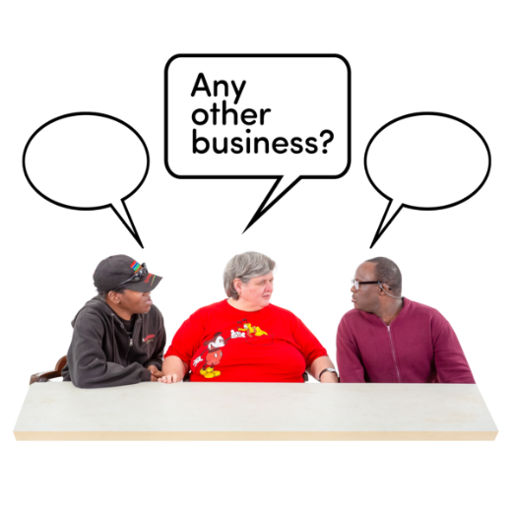 | 15. Any other business  There were 2 questions about sick pay and Personal Assistants payment dates.
Nic said that her National Insurance payments were not matching her HMRC details.

Emma gave some advice.
 |  |  |  | 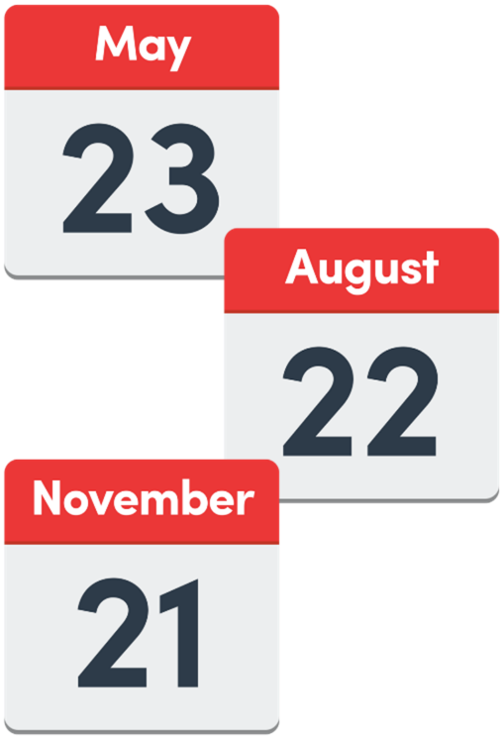 | 12. Dates of the next meetings  The next meetings will be on:  - Monday 23 May 2022  - Monday 22 August 2022  - Monday 21 November 2022
 |  |  |  | 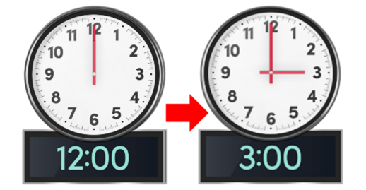 | All the meetings will be from 12 noon to 3.00pm.
 |  |  |  |  | This is the end of the Minutes.

