Independent Living Fund Scotland

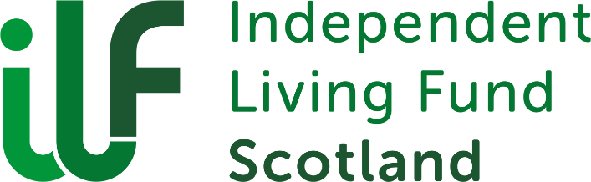

Scotland Advisory Group Meeting Minutes
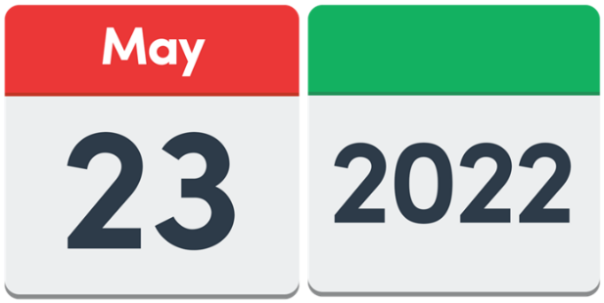
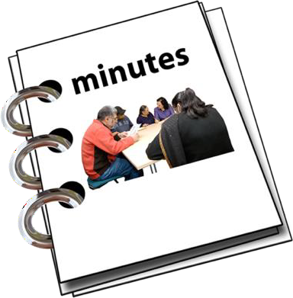
23 May 2022
Easy Read

Copyright images © Photosymbols. Prepared by Disability Equality Scotland

 |  |  | 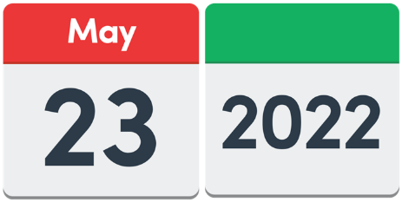 |  |  | The meeting happened on Monday 23 May 2022 from 1pm to 3pm.
 |  |  |  |  |  | The meeting happened face to face at Glasgow Centre for Inclusive Living and also on Zoom.
Who was at this meeting?
Jim Elder-Woodward
Andy Higgins
Nic Reid
Kate Walsh (online)
Joan Turner (joined online at 3.22pm)
Lee House
Linda Scott
Robert White
Emma O’Neill (online)
Catherine Montgomery (online)
Sandra Sweeney (joined at 2.20pm)

Who could not come?
Chloe Mckee
Gordon Mckee
Christine Mercer

4 Actions from this meeting

- Lee will send out electronic forms when Ann Cowan has finished them.

 |  | 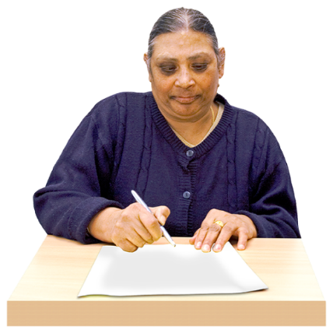 |  |  |  | 2. Linda will write a draft reply about the plan for a new Disability Commissioner.  She will send it out to the group, to see if there are any changes to make.
 |  | 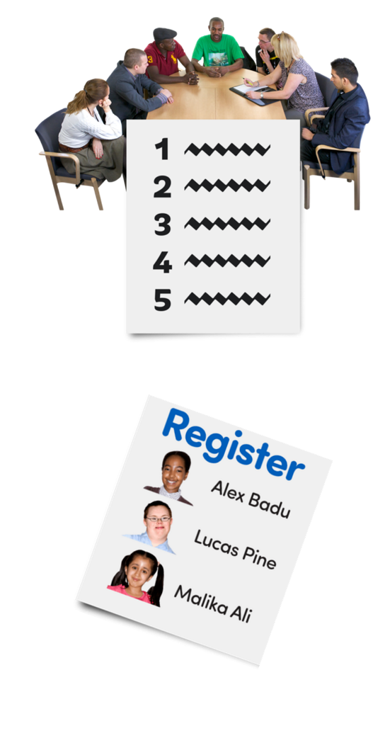 |  |  |  | 3. Lee will put these things on the next meeting agenda:  - planned registration of Personal Assistants  - planned rules about Personal Assistants  Registration means making a list of people who have joined.
 |  | 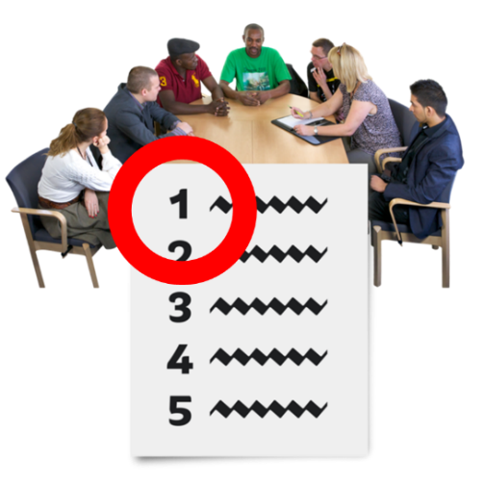 |  |  |  | 4. Lee will make sure that the Terms of Reference is talked about earlier in the next meeting.  He will put it nearer the beginning of the meeting agenda.
1. Welcome and Introductions
Jim welcomed everyone.
He asked if everyone was okay with the meeting being recorded.
Everyone agreed.

2. Minutes and Actions from the last Meeting
The Minutes did not need any changes made.
They will be put on the website.
Actions from the last meeting
Lee will send out the electronic forms for the group to look at, as soon as they are ready.
This is still being worked on.

 |  |  | 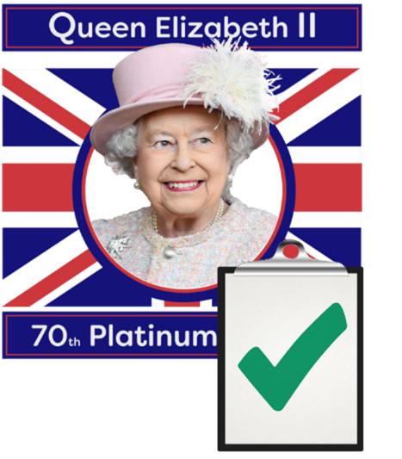 |  |  | Peter and Linda will talk to the sponsor team about possibly having a public holiday for Personal Assistants, for the Queen’s Jubilee.  This has been done.
Linda will send a new copy of the Terms of Reference to everyone in the group.
This has been done.
 |  |  | 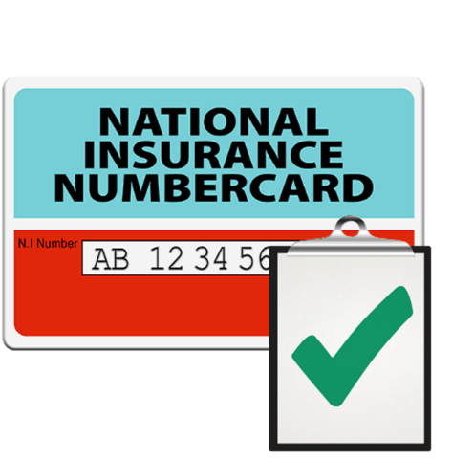 |  |  | Linda will share information about Employer National Insurance costs.  This has been done.
3. Any other things we need to talk about
There was nothing extra to talk about.
- Scottish Social Care wages going up

Wages mean the money that a worker is paid for doing their job.

The Independent Living Fund Scotland added 5 and a half percent to all awards from 1 December 2021.
The new Social Care wage is 10 pounds and 50 pence an hour. This started on 1 April 2022.

 |  |  |  |  |  |  | The Independent Living Fund Scotland added 4 point 8 percent to Personal Assistants rates from 1 April 2022.
 |  |  | 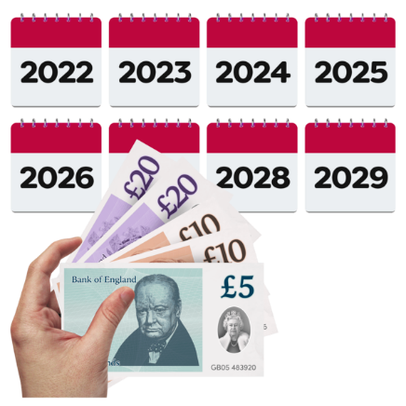 |  |  |  | Independent Living Fund Scotland will look at putting up provider rates in the future in each case.  In this document, providers are organisations like care agencies.
Award Managers must get a copy of the letter about pay rises from the provider.
They must send this letter to the Independent Living Fund.

 |  |  | 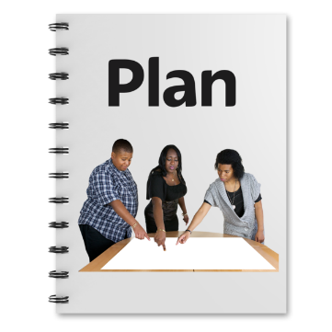 |  |  |  | - The Disability Commissioner Bill plan
 |  |  | 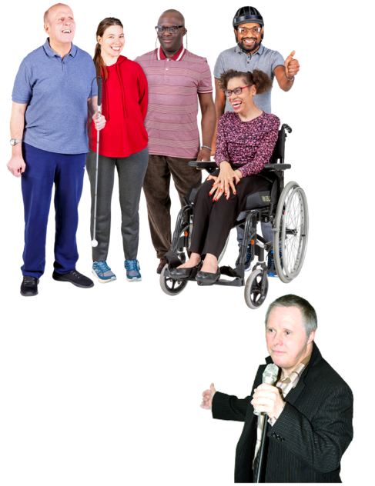 |  |  |  | A Member of Scottish Parliament wants to make a new job called a Disability Commissioner.  A commissioner is someone who speaks up for a group of people.  A Disability Commissioner speaks up for disabled people.
 |  |  | 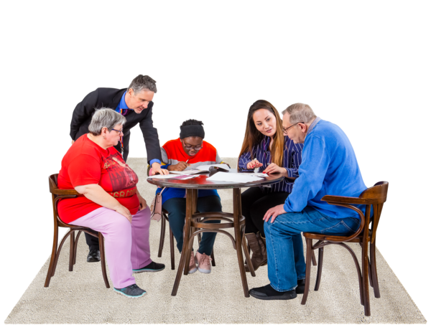 |  |  |  | The group said that they will write a reply about this plan.
- Possibly opening the 2015 Fund again

Jim said that he asked Kevin Stewart – the Minister for Mental Wellbeing and Social Care – about opening this fund again.

Mr Stewart said that the Scottish Government wants to open it again.

But the fund needs to be able to have enough money in the future.

7. Policy Updates

Linda told everyone about the COVID-19 Sustainability payments.

These payments are given to care providers during the pandemic to help them carry on their business.

The Scottish Government wants services to go back to normal from 1 July 2022.
Most of these payments will stop then.

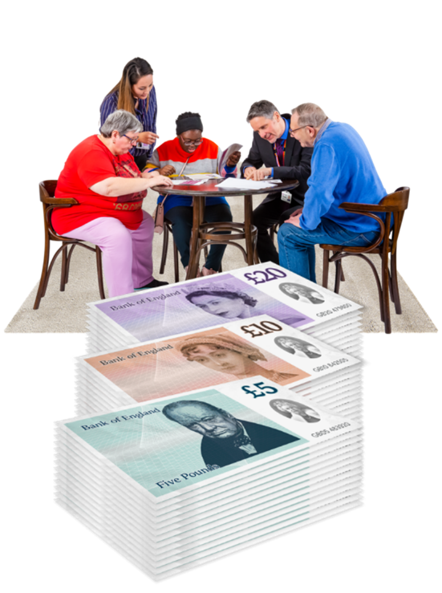 |  |  |  |  |  |  | Hourly rates for Personal Assistants are going up.  This means that people’s awards are getting higher. They are reaching the maximum amount that Independent Living Fund can pay out.  Independent Living Fund Scotland is talking to the Sponsor Team to see what the choices are.
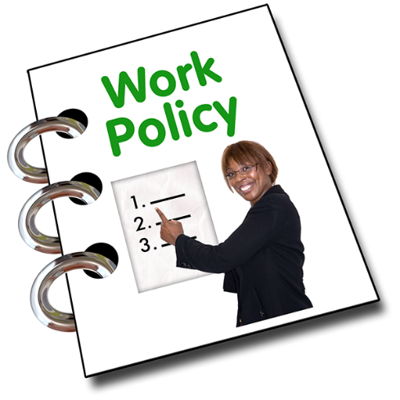 |  |  |  |  |  |  | Policy 26 is called Managing an Independent Living Fund Scotland Award.  Linda has sent the new Policy 26 to all the group members for their thoughts.  It makes the different roles clearer.
Linda told the Group that some Assessors had asked about Policy 31 – Relatives Living with Recipients as a Paid Personal Assistant.

They wanted to know if the Policy should have ‘close relationship’ instead of ‘relatives’.

The Group agreed.

Linda will talk with the Sponsor Team about this.

8. Award Schedule, Contingency Funds and Holidays

Contingency Funds mean money that is saved up just in case it is needed.

Linda said that the Group had talked about changing payments so that recipients can look after their money more easily.

The Finance Team have been asked for their thoughts on these changes.

 | 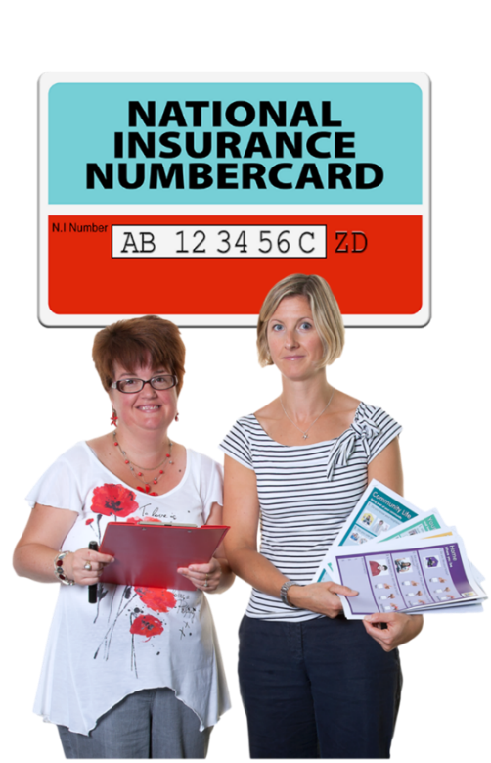 |  |  |  |  |  |  | There was lots of talk about National Insurance contributions.  This is the money paid by employers to the Government.  Linda said she will sort out:  - advice  - training  - information in the newsletter
9. Review Visits

Robert said that Reviews are happening again.
Most people want a face to face visit.

 | 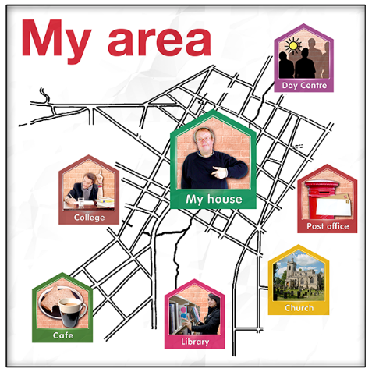 |  |  |  |  |  |  | Some Local Authorities have not gone back to the same funding and support that they were giving before COVID-19.  Independent Living Fund Scotland is trying to sort this out at reviews.
10. Feedback about Electronic Forms

Lee will email out the electronic forms for the Group to see when he has heard back from Ann Cowan.
 |  |  | 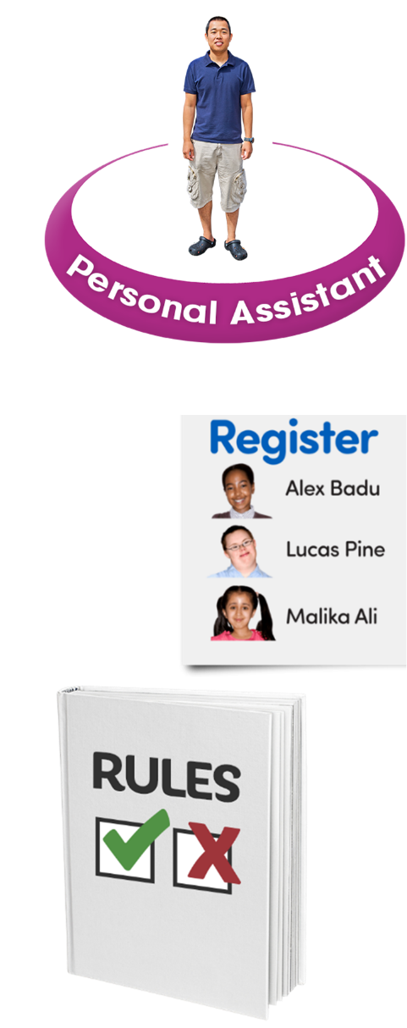 |  |  |  | 11. Personal Assistants Register and Rules  A register is a list of names and details.  Jim said that the Scottish Government wants Personal Assistants to:  - be on a register  - follow the same rules  He said this is quite tricky – for example, sorting out different training needs.
 |  |  |  |  |  |  | Andy said at the moment Personal Assistants will be allowed to choose if they want to be on the register or not.
 |  |  | 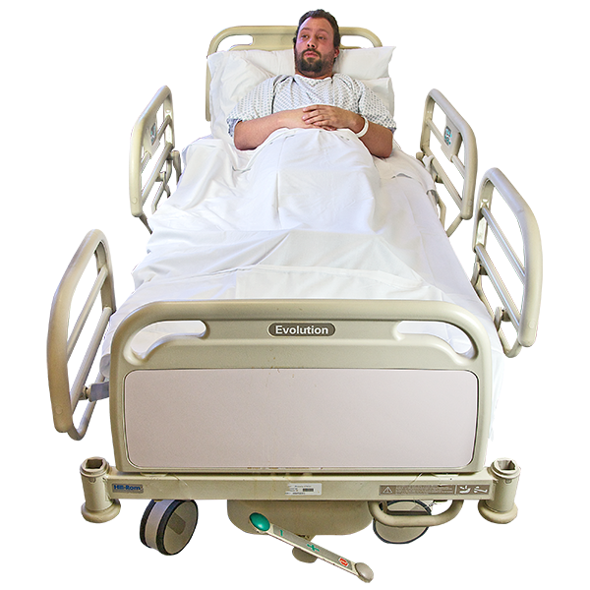 |  |  |  | 12. Staying in hospital  The Independent Living Fund Scotland stops payments if a recipient has stayed in hospital for 28 days or longer.  But during COVID-19 they did not do this.
 |  |  | 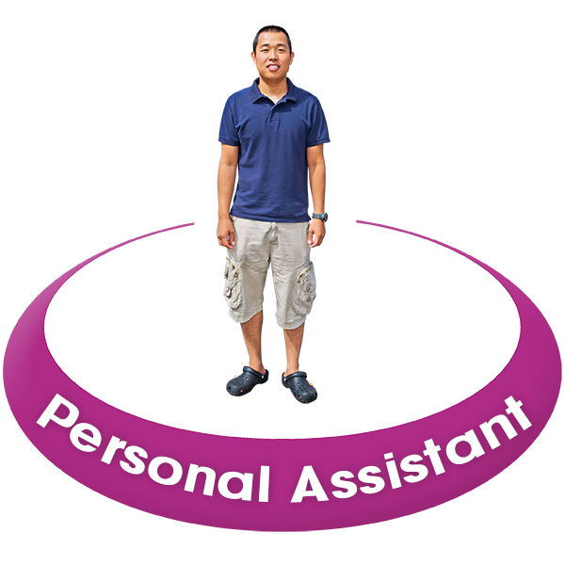 |  |  |  | The Group talked about how important it is for Personal Assistants to support some recipients in hospital.  Linda said that people should speak to the Independent Living Fund caseworker team if they need this support.  They will see if payments can carry on.
 |  |  | 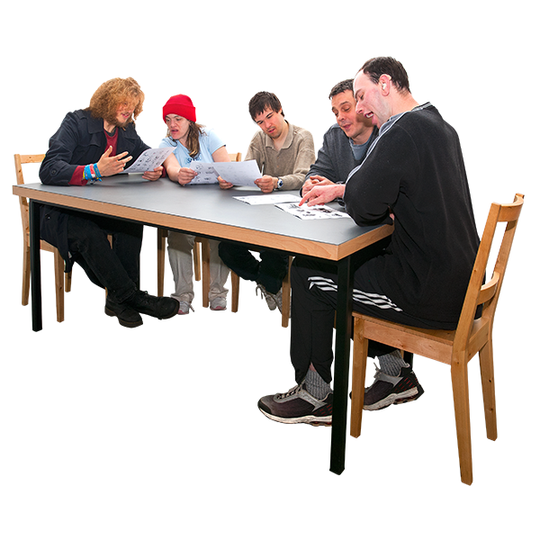 |  |  |  | 13. Charter for Involvement  Linda asked if the Group could have extra meetings to see what still needs to be done in the Charter for Involvement Action Plan.
 |  |  |  | 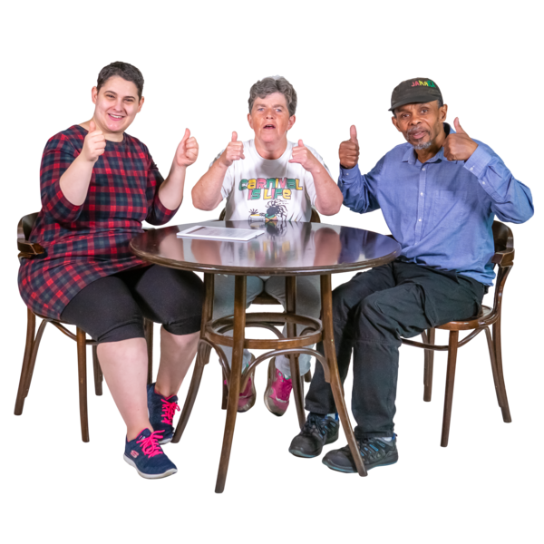 | 14. Terms of Reference  Andy asked if the Group could be given a new shorter name of ‘Scotland Advisory Group’.  Everyone agreed.
 |  |  |  | 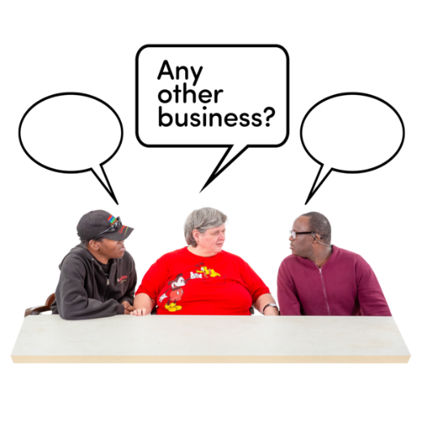 | 15. Any other business  There was nothing else to talk about.
 |  |  |  | 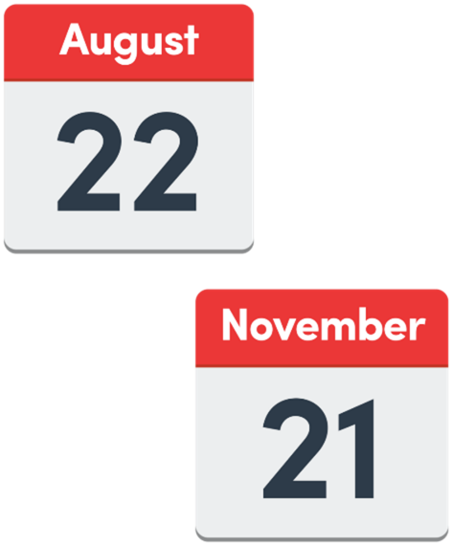 | 16. Dates of the next meetings  The next meetings will be on:  - Monday 22 August 2022  - Monday 21 November 2022
 |  |  |  | 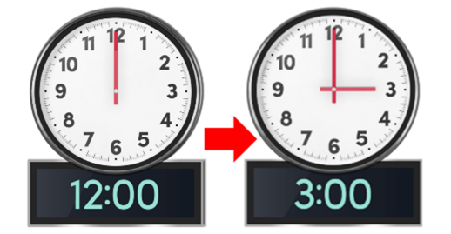 | Both the meetings will be from 12 noon to 3.00pm.
 |  |  |  |  | This is the end of the Minutes.

