# A green and white logo Description automatically generatedIndependent Living Fund Scotland

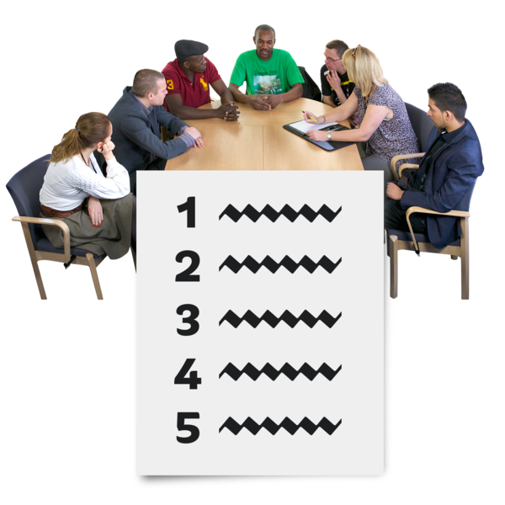**Re-opening Event Agenda**



## About this document

|  |  |
| --- | --- |
| A meeting table with 7 people. At the front is a list with numbers. | This is an Easy Read **agenda**.  An **agenda** tells you what will happen at an event. |
| A woman with a microphone, standing talking to people sat looking relaxed at small tables. | This is the agenda for Independent Living Fund Scotland’s first online event about the fund opening again. |
|  | It is happening online via Zoom on Thursday 11 January 2024. |
| A circle of minutes, with 15 short red lines and 45 short grey lines. It says 15 minutes in the middle of the circle. | In this document pictures like this one will show you how long each part of the event will take. |

## About your needs

|  |  |
| --- | --- |
| A pair of headphones. A hand touching a braille document. An easy read booklet. A large print booklet. | If you need information in a different way – like:   * audio * braille * Easy Read * large print   please tell us as soon as possible. |
| A woman in a wheelchair, a ramp, an Easy Read document and a timer. She is saying 'I need...'. | If you will need support at any point during the day, please tell us. |
| 2 hands typing an email. | 1. You can email us at [Geraldine.Higgins@ILF.scot](mailto:Geraldine.Higgins@ILF.scot) |
| A man using his phone. | 1. You can phone us on   **0300 200 2022** |

## The Agenda

|  |  |
| --- | --- |
| A clock showing 11am A 60 minute clock face with 15 minutes in red and the rest in grey. | **11am** – The event starts with a welcome by Peter Scott. |
| A clock showing 11.15 A 60 minute clock face with 15 minutes in red and the rest in grey. | **11.15am** – Group chats about:   * the **Threshold Sum** * the **Maximum Award** * **Age** |
| A man holding an Easy Read document. | You can find out more about these **bold** words in the Easy Read document called ‘What we will talk about’. |
| A clock showing 11.45 A 60 minute clock face with 20 minutes in red and the rest in grey. | **11.45am** – People who have come along can choose to share what their group talked about. |
| A clock showing 12.05  . A 60 minute clock face with 30 minutes in red and the rest in grey. | **12.05pm** – Group chats about:   * **Available Income Contribution** * **Capital Threshold** |
| A clock showing 12.35 A 60 minute clock face with 45 minutes in red and the rest in grey. | **12.35pm** – Lunchtime. |
| A clock showing 1.20 A 60 minute clock face with 20 minutes in red and the rest in grey. | **1.20pm** – People who have come along can choose to share what their group talked about before lunch. |
| A clock showing 1.40 A 60 minute clock face with 30 minutes in red and the rest in grey. | **1.40pm** – Group chats about:   * Working well with **Local Authorities** * **Additionality** * How Independent Living Fund money is used |
| A clock showing 2.10 A 60 minute clock face with 20 minutes in red and the rest in grey. | **2.10pm** – People who have come along can choose to share what their group talked about. |
| A clock showing 2.30 A 60 minute clock face with 30 minutes in red and the rest in grey. | **2.30pm** – Time for any questions and a finishing talk. |
| A clock showing 3pm. | **3pm** – the event ends |