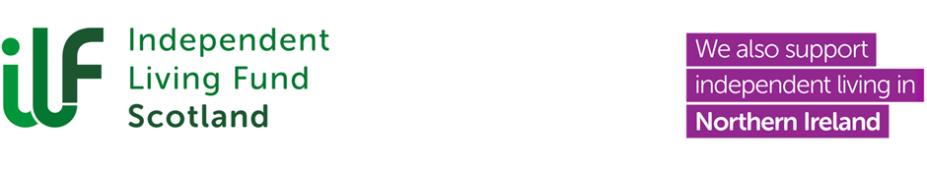

Charter for Involvement Action Plan
Summary of Progress 2024 to 2025

Background
The Charter for Involvement was developed by the National Involvement Network, supported by ARC Scotland. The Charter establishes how disabled people who use support services want to be involved and to have a say about the services they receive, the organisations that provide their services, and their wider communities.

Introduction
ILF Scotland signed up to the Charter for Involvement in 2018 and we worked with the Advisory Groups to tailor the Charter Statements so that they were meaningful to our recipients. We co-produced the Charter and Action Plan and published this in April 2021.

This report provides an update to the Board on the progress made during 2024 to 2025. This update was shared and agreed by our Senior Management Team at its meeting of 22 April 2025 and by the Equalities Committee at its meeting of 30 April 2025 and published on our website on that date.

Key Progress
Three joint Scotland and NI Advisory Group meetings were held during the year to review progress to date and identify Charter priorities for ILF Scotland to action. These are highlighted below along with progress made during 2024 and 2025.

Independent Living

Group members stressed the importance of raising awareness of the meaning of ‘Independent Living’ to a wide range of Stakeholders.

Response: Advisory Group members held a joint event in the Scottish Parliament at the end of March 2024, facilitated by ILF Scotland, which focussed on the power of Independent Living, with Group members giving presentations. Following on from this successful, well attended event, Group members have continued to contribute by participating in PR / Marketing campaigns - sharing their stories and raising the profile of disabled people and through this, promoting independent living. Members also attended co-production engagement events to develop ILF Scotland’s next strategic plan, a key stated priority in the plan is to enable more disabled people to access our funds to live independently. The Groups will be fully involved in co-producing two 10 year celebratory events in June 2025, one in Scotland and one in Northern Ireland and again, will use this opportunity to promote Independent Living.

PA Recruitment
Group members discussed the significant difficulties people are experiencing in relation to the recruitment and retention of Personal Assistants (PAs) and asked for ILF Scotland to help promote the role.

Response: We co-produced a PA recruitment campaign with members and as part of this, we updated our website with information and signposting to useful sources e.g. SDS recruitment toolkit and My Job Scotland website. We also produced three blogs from current recipient PAs where they describe their role and what it means to them, and we are working on sourcing and / or producing videos highlighting the role of a PAs and how it differs from paid carers. In addition, we engaged with the PA Network Scotland to link into national initiatives and through Inspiring Scotland, met with the local Support in the Right Direction (SiRD) organisations with a view to signposting to local support available in Scotland.

Managing ILF Scotland Awards
Members provided feedback on the role of the Award Manager and highlighted the need for further information and advice for Award Managers on, particularly given the new roles emerging as a result of the re-opening of ILF in Scotland. Areas should include employer commitment, PA recruitment and retention, and independent advocacy.

Response: We have established an internal working group of SDS Assessors and Caseworkers to focus on award management, explore issues and make suggestions initially, which we will then discuss further with Group members. We plan to update our Employer Support Information Note and our Your Responsibilities Guide in 2025 to 2026. PA recruitment is covered above.

ILF Scotland Recipient Reviews
Group members highlighted the need for continuously improving information, communication, and processes at all stages of reviews. Specifically, that we continue to make sure that recipient choice is central to review discussions and outcomes.

Response: One of our SDS Assessors now attends meetings with the Advisory Groups to discuss Charter work and acts as the liaison between the Group and the ILF Scotland team to help ensure we facilitate good communication and discussion and take suggestions on board in planning and conducting reviews and in relation to staff training.

Engagement and Involvement
Group members value the opportunity to influence policy and practice as it affects recipients and to co-produce key documents and initiatives.

Response: Group members in Scotland met with the Minister for Mental Health, Social Care and Sport on two occasions to discuss ILF Scotland policy and influenced and contributed to several award policy updated during 2024 to 2025. Members also attended and contributed to a series of online and in person engagement events to co-produce our next organisational Strategy for 2025 to 2028 and as stated above, will co-produce our 10 year celebratory event.

Written Communication
Group members have stressed the importance of clear communication by ILF Scotland that is as accessible as possible.

Response: Members were fully consulted in the review and publication of external communications such as our website, newsletters, and letters to recipients, with a focus on both content and accessibility. Members were jointly involved in all external consultations that ILF Scotland responded to in 2024 and 2025. Members have been involved in the co-production of our new Feedback Strategy and Service Charter.

Re-Opening of ILF in Scotland
The overall aim of the Charter is to ensure that recipients have a greater say and influence in the way that services are delivered. The Scotland Advisory Group was instrumental in advocating, along with others, for the re-opening of ILF to new applicants in Scotland from April 2024. Since reopening, an additional 700 recipients have been awarded funding. The Chairperson and the Depute Chair of the Scotland Advisory Group is a member of the ongoing Co-Production Working Group who guide and inform the policy framework relating to the re-opened fund.

Conclusion
We have made significant progress against the Charter Action Plan during 2024 to 2025. It is important that this improvement work is ongoing and we will continue to work with the Advisory Groups in 2025 to 2026 to make further progress towards achieving the Charter Standards. The Charter provides a valuable opportunity to help facilitate greater collaboration with recipients, via the Advisory Groups, in the organisation’s strategy, policies and delivery of services. We are grateful to Group members for their valuable ongoing commitment to improving our services to disabled people in Scotland and Northern Ireland.

